**Introduction of MCP:**

MCP is an open protocol that standardizes how applications provide context to LLMs. Think of MCP like a USB-C port for AI applications. Just as USB-C provides a standardized way to connect your devices to various peripherals and accessories, MCP provides a standardized way to connect AI models to different data sources and tools.

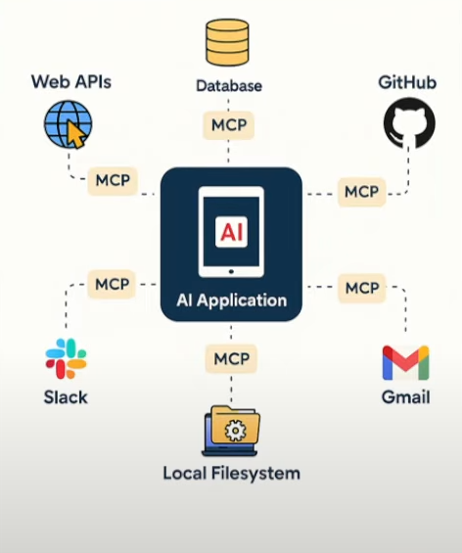

* **Why MCP:**

Modern applications increasingly rely on **Large Language Models (LLMs)** that must dynamically interact with **multiple tools, databases, APIs, and files**. Traditional RESTful APIs struggle with this because they:

* Require manual integration and boilerplate per tool.
* Lack context awareness and persistent state.
* Don’t support dynamic tool discovery or bidirectional communication.

**Model Context Protocol (MCP)** solves this by standardizing how LLM-based apps **discover**, **invoke**, and **interact** with tools in a structured, contextual, and modular way.

**It enables:**

* **Dynamic, pluggable tools** with self-describing schemas.
* **Context sharing** (memory/state) across tools.
* **Asynchronous interactions** like notifications or background tasks.
* **Reduced N×M complexity** for tool integrations.
* **Learn Few Terminologies:**

Learn few terminologies like: **MCP Host**, **MCP Client**, **MCP Server**, **MCP Protocol**, etc.

1. **MCP Host:**

The **MCP Host** is the LLM-powered application or environment (e.g., Claude Desktop, a chat UI, or IDE) that wants to access external information or tools—but cannot talk to them directly.

* Acts as the “**chef**” who needs ingredients (data), but doesn’t fetch them.
* Example: Claude Desktop **wanting to query** a Postgres database.
* Hosts orchestrate the conversation and manage multiple tool interactions.
* Uses **MCP Clients** internally to connect to tools.

1. **MCP Client:**

The **MCP Client** is the **connector** within a Host that translates LLM requests into MCP messages and sends them to servers.

* Like the “waiter” taking orders from the chef.
* Example: MCP client inside an IDE that calls GitHub or file-system MCP servers.
* Maintains one-to-one connections to each MCP Server.
* Handles JSON-RPC communication (requests, responses, notifications).

1. **MCP Server:**

The **MCP Server** is a lightweight service exposing specific capabilities—such as databases, files systems, and web APIs— via MCP.

* Acts like the “supplier” who delivers ingredients/tools.
* Example: PostgreSQL MCP Server that runs SQL queries and returns results.
* Servers are **self-describing**, sharing schema, tools, annotations, and capabilities.
* Can wrap local resources (e.g., files) or remote services (e.g., Slack, Stripe).

1. **MCP Protocol:**

The **Model Context Protocol** standardizes how Clients and Servers communicate via **JSON-RPC 2.0** over **stdio or HTTP+SSE**, enabling dynamic tool use and context exchange.

* Defines messages: requests (tool calls), notifications, and responses.
* Supports tool discovery, structured inputs/outputs, and **persistent context.**
* Enables bidirectional communications: Servers can notify Clients or request model samples.
* Example types:
  + **Resources**: read-only context like database views.
  + **Tools**: actions like “run_sql” or “create_chart.”
  + **Sampling**: server asks model to generate summary of data.
* **Communication between Components:**

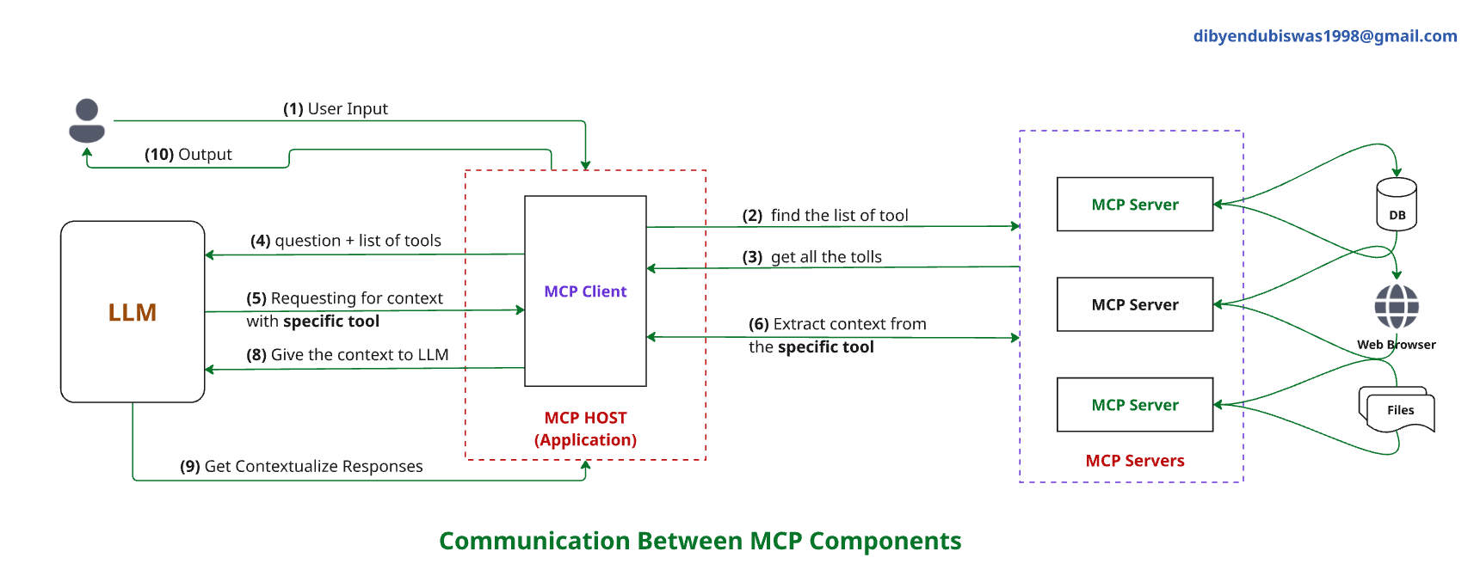

1. **User Input:** A user provides input (e.g., a question or command) to the system.
2. **MCP Client requests tool list:** The MCP Client (inside the MCP Host / Application) queries available MCP Servers to **find the list of tools** they provide.
3. **MCP Client collects tool descriptions:** The MCP Client **retrieves metadata** about the available tools from all MCP Servers (e.g., what methods they support, input/output schemas).
4. **LLM receives questions + tools list:** The MCP Client gives the LLM the user’s question and the list of available tools for reasoning.
5. **LLM selects a specific tool for the task:** The LLM decides which tool(s) to call based on the user input and tool capabilities, then forms a tool request.
6. **MCP Client send the tool call:** The MCP Client forwards the LLM’s tool request (via JSON-RPC) to the **specific MCP Server** that hosts the tool.
7. **MCP Server processes and extracts context:** The MCP Server performs the requested operation (e.g., DB query, file processing, API call) and generates output.
8. **MCP Client returns tool response to LLM:** The result from the tool is passed back to the LLM for integration into its reasoning.
9. **LLM generates contextualized response:** The LLM uses the tool output as part of its overall response formulation.
10. **Final Output to User:** The user receives a rich, contextualized answer that combines the LLM’s reasoning and the tool’s output.

* **Real World Example:**

**Scenario: K12 Chatbot with Agentic Capabilities**

You're building an AI-powered chatbot that helps students with:

* Answering subject-specific questions (Math, Science, etc.)
* Generating MCQs or quizzes.
* Fetching summaries from textbooks.
* Displaying charts or solving equations.

**Key Components in these Applications:**

1. **MCP Host (K12 Chatbot Application):**

* This is your main chatbot interface (e.g., built with **LangChain** or **LangGraph**).
* It includes the **LLM agent** that interacts with students.
* It needs access to textbooks, quiz generation tools, image/video explainers, etc., but doesn’t connect directly to them.
* **Example**: A LangChain app with memory and state management

1. **MCP Client (Connector Layer):**

* Resides within the host (chatbot) and connects to different MCP Servers.
* Translates AI’s internal requests into structured MCP tool calls.
* Maintains **persistent state and tool discovery.**

1. **MCP Servers (Your Tool Providers):**

You can create various servers depending on the tools you want your chatbot to access:

* **Textbook Reader Server:** Exposes subject-specific PDFs or markdown notes as a resource.
* **Quiz Generator Server:** A tool that takes a topic and returns 5 MCQs.
* **Math Solver Server:** Accepts math expressions, returns LaTeX-rendered solution or graph.
* **Video/Animation Server:** Calls external APIs to return animated video explanations.

Each of these servers self-describes its tools (e.g., generate_quiz, read_topic, solve_equation).

1. **MCP Protocol:**

* The standard that **connects your client and servers**.
* Uses **JSON-RPC 2.0** over:
  + **HTTP + Server-Sent Events (SSE)** for web-hosted tools.
  + **stdio** for local resources or offline apps
* This enables your chatbot to:
  + Discover which tools are available.
  + Understand each tool’s input/output schema.
  + Maintain session context (like memory of what topic is being discussed).
  + Receive **notifications** (e.g., “quiz ready!”).

**Why MCP is perfect for this:**

* **Dynamic tool discovery**: Add new subjects/tools without coding changes in the chatbot.
* **Persistent state**: Student topic context and progress retained across multiple questions.
* **Security and isolation**: Each tool runs in its own **MCP** **Server** (e.g., quiz generator can't access DB directly).
* **Scalable & modular**: You can scale servers independently (e.g., separate quiz service per grade).

**Note:**

If you have **50 different tools**, you do **not necessarily need 50 servers**, but you can, depending on your architecture and design goals. Here’s a breakdown based on **Security**, **Isolation**, and **Scalability** using **MCP:**

1. **Security & Isolation:**

**Why separation helps:**

* Each **MCP Server** runs in its **own process or container**.
* If a tool is compromised, the damage is isolated.
* Sensitive tools (e.g., **student_db_tool**) can run in a **secure environment** with access control.

**Example:**

* **Quiz_generator** cannot access **student_grades_tool** or **admin_tools** unless explicitly allowed.
* You can sandbox tools that run untrusted code (e.g., **code_executor_tool**).

**Conclusion**: Creating separate servers per sensitive or critical tool enhance **security and isolation**.

1. **Scalability & Modularity:**

**Why modular servers help:**

* Tools with **heavy load** (e.g., **video_generator**, **text_summarizer**) can scale independently.
* You can deploy tool servers on different machines or even in the cloud (e.g., AWS Lambda, containers).
* Developers can work on tools independently and deploy updates without affecting the rest of the system.

**Example:**

* **math_solver**, **textbook_parser**, and **speech_to_text_tool** are hosted separately and scaled based on demand.

**Conclusion:** Splitting tools into modular **MCP** **Servers** allows **horizontal scaling** and better resource management.

* **Comparisons between APIs vs. MCP:**

**Similarities between APIs vs. MCP:**

|  |  |
| --- | --- |
| **Aspect** | **Descriptions** |
| **Communication** | Both are mechanisms for communication between clients and services/tools. |
| **Data Exchange** | Both use structured data (usually **JSON**) to send and receive information. |
| **Request/Response** | Both follow a pattern where a client sends a request and gets a response. |
| **Interoperability** | Both allow integration of multiple services and tools, often over HTTP. |
| **Can be Secured** | Both support secure communication (e.g., via **HTTPS** or internal auth). |

**Difference between APIs and MCP:**

|  |  |  |
| --- | --- | --- |
| **Criteria** | **Traditional APIs** | **Model Context Protocol (MCP)** |
| **Designed For** | Human/frontend clients (browsers, apps). | LLMs and autonomous agents. |
| **Interface Type** | RESTful (HTTP verbs, endpoints like /**getData**). | JSON-RPC method calls like **run_tool**, **generate_quiz**. |
| **Tool Discovery** | Manual (**Swagger**/**OpenAPI**) or hardcoded. | Automatic, self-describing tools (metadata sent by each **MCP** server). |
| **Context Awareness** | Stateless — no memory between requests. | Contextual — LLMs retain memory across multiple tool calls. |
| **Protocol Structure** | URI-based, with route handlers (/**user**/**5**). | RPC-like calls with tool names as methods and parameter dicts. |
| **Dynamic Tool Calling** | Not native, requires orchestration logic. | Built-in — LLMs can reason and call new tools in real-time. |
| **Latency Handling** | Synchronous by default. | Supports **async** patterns (like server push, background jobs via notify, etc.) |
| **Scalability Model** | One endpoint per functionality or microservice. | One MCP Server per tool or group of tools — more modular, LLM-aware. |
| **Use Case Fit** | CRUD apps, frontend/backend separation. | LLM agents, tool chaining, AI orchestration (e.g., agents solving tasks using many tools). |

**JSON-RPC, StdIO and HTTP + SSE:**

Here's a clear and complete explanation of **JSON-RPC**, along with **StdIO** and **HTTP + SSE** in the context of **Model Context Protocol** (**MCP**) and real-world applications:

* **JSON-RPC:**

**JSON-RPC (JavaScript Object Notation – Remote Procedure Call)** is a **lightweight protocol** used to make **remote method calls** using JSON. It allows a client (like an LLM or frontend) to call methods on a remote server as if calling local functions.

* **Key Characteristics:**
  + Language-agnostic.
  + Uses JSON for requests and responses.
  + Supports **method names**, **parameters**, and **IDs.**
  + Supports **notifications** (one-way messages without expecting a response).
* **JSON-RPC Request Example:**

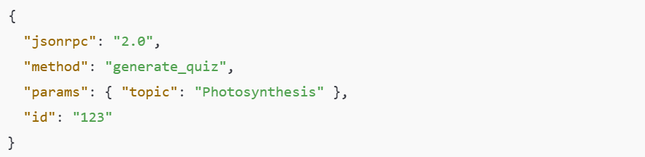

* **JSON-RPC Response Example:**

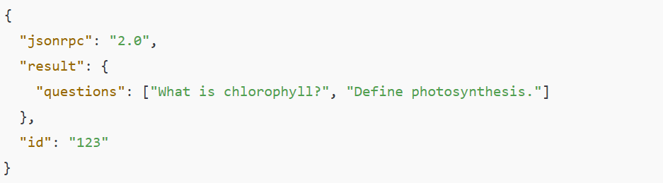

* **Real-World Example (K12 Chatbot):**

A **K12 chatbot** wants to generate a quiz based on a topic.

**Instead of calling a REST API like:**



**The LLM uses JSON-RPC:**

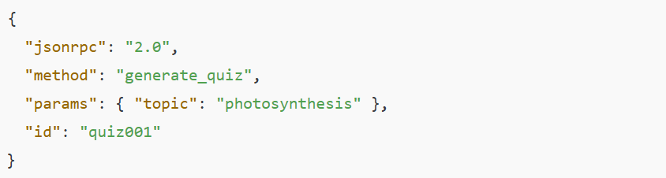

**Why this helps:**

* The tool is **self-describing**.
* Easy to **chain tools dynamically**.
* Method-focused, not URI-focused.
* **StdIO (Standard Input/Output) in MCP:**

**StdIO** is a communication pattern where the **MCP server communicates via command-line input/output** streams.

* **Example Use Cases:**
* An LLM agent launches a **local Python script tool** (like a math solver).
* The tool receives JSON-RPC via **stdin** and writes responses via **stdout**.

**Request on stdin:**

$ echo '{ "method": "solve_equation", "params": {"eq": "x^2 - 4 = 0"}, "id": 1 }' | python mcp_tool.py

**Tool responds on stdout:**

{ "result": ["x = -2", "x = 2"], "id": 1 }

* **Ideal For:**
  + Running tools locally or in sub-processes.
  + Lightweight deployment.
  + **CLI**/**terminal**-**based** agent systems.
* **HTTP + SSE (Server Sent Event):**

MCP over **HTTP + SSE** allows clients to send **JSON-RPC** calls over **HTTP** and receive **streamed responses** from the server in real time.

**SSE** = one-way push from server to client (good for streaming answers, like LLM outputs).

* **Example Use Cases:**
  + A user requests **summarize_document**
  + The server sends **updates line-by-line** via SSE:

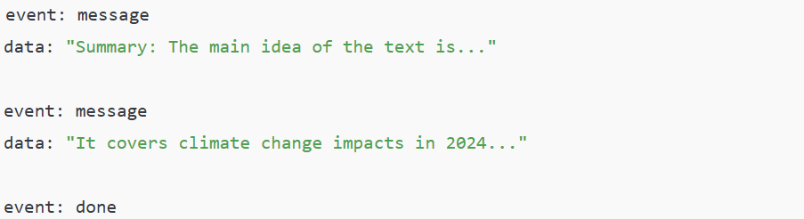

* **Ideal For:**
* Streaming large outputs (e.g., **LLM** responses).
* Web applications that need real-time updates.
* Cloud-hosted **MCP** servers.
* **Summary Table:**

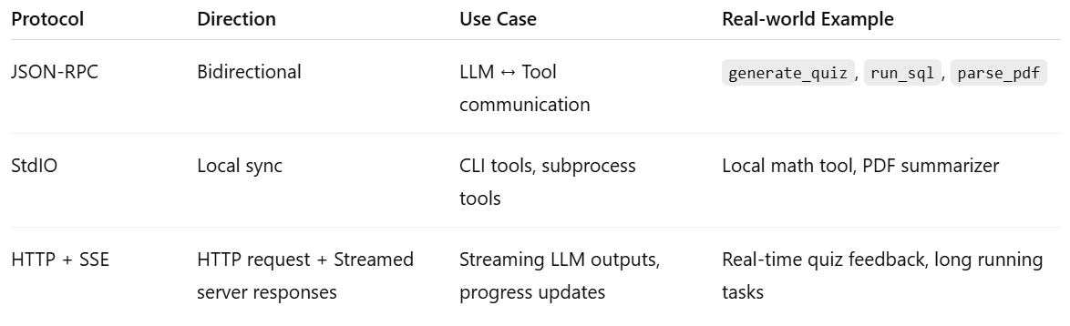

* **How MCP Standardizes Communication:**

**Model Context Protocol (MCP)** defines a **uniform way for LLMs and tools to interact**, regardless of where or how those tools are hosted.

* **Key Components:**

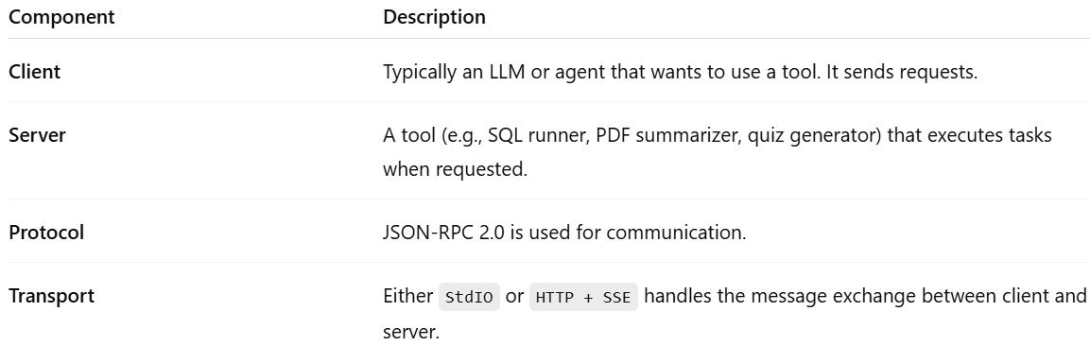

* **Transport Options:**

**StdIO (Standard Input/Output):**

MCP Client ⇄ MCP Server communicate via terminal I/O streams.

* **When to Use:**
  + Local tool execution (e.g., subprocesses tools)
  + Lightweight environments.
  + When low-latency matters or when deploying on CLI.
* **Example:**
  + An LLM spawns a Python tool via subprocesses
  + Sends JSON-RPC to its **stdin**
  + Receives JSON output from **stdout**

**HTTP + SSE (Server Sent Events):**

JSON-RPC over HTTP requests, with **streamed responses** via SSE.

* **When to Use:**
  + Remote/cloud-based MCP servers
  + Need to **stream long outputs** (e.g., LLM completions)
  + Web integrations
* **Example:**
  + MCP client POSTs {"method": "**generate_quiz**"} to /**rpc**
  + Server streams quiz questions line-by-line via **SSE**
* **When to Use Each Options:**

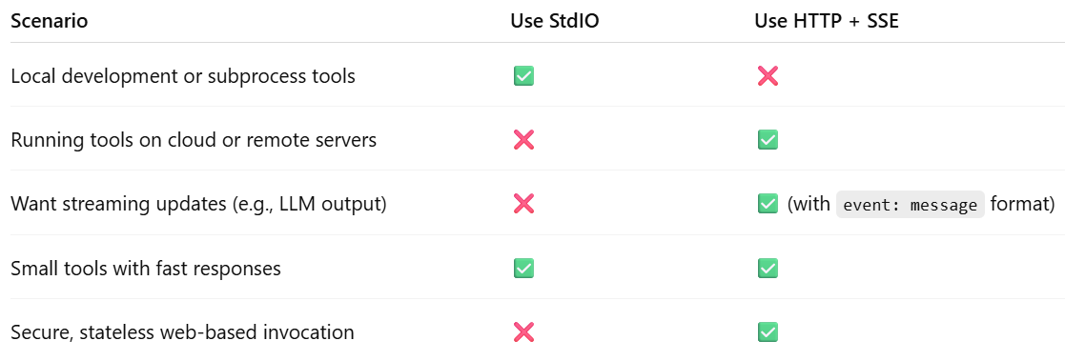

* **Summary:**
* **MCP standardizes** how tools (**servers**) describe themselves and how LLMs (**clients**) call them using **JSON-RPC 2.0.**
* It abstracts away the transport layer — whether it's **Stdio for local tools** or **HTTP + SSE for cloud services** — enabling **tool discovery**, **context sharing**, and **AI-native orchestration**.
* It's optimized for **LLM-first architecture**, making it **scalable**, **modular**, and **contextual**.

**Difference between Function Call and MCP:**

|  |  |  |
| --- | --- | --- |
| **Aspect** | **Function Call** | **MCP (Model Context Protocol)** |
| **Scope** | LLM calls pre-registered functions/tools **inside one API (e.g. OpenAI API)** | LLM calls external tools/servers dynamically via **JSON-RPC** |
| **Tool Discovery** | Functions must be **registered in the API request** (no discovery) | Tools **self-describe** at runtime; dynamic discovery possible |
| **Execution Location** | Functions handled within API environment | Tools run anywhere (local, cloud, separate services) |
| **Transport** | Encoded in LLM API request/response | StdIO or HTTP + SSE for tool communication |
| **State/Context Sharing** | No cross-call memory (unless implemented manually) | Sessions enable context sharing across multiple tool calls |
| **Flexibility** | Limited to what’s embedded in the LLM provider’s API | More modular: tools live independently and can scale separately |
| **Streaming & Async** | Limited (depends on provider) | Built-in async, streaming via SSE |

**When to use Function Call and When to use MCP:**

Let’s explore when to use Function Call or when to use MCP:

* **When to use Function Call:**
* You want a **simple integration** inside your LLM API call (e.g. OpenAI, Anthropic).
* Your tools are **small, deterministic, and lightweight**.
* You don’t need independent deployment, scaling, or dynamic discovery.
* **Example:**
  + Call weather API, calculator directly within LLM API request.
* **When to use MCP:**
* You want your LLM to access **external, independently running tools.**
* You need **dynamic tool chains** where tools can be added/removed at runtime.
* You need **modular, scalable architecture** (e.g., microservices for AI agents).
* You want **persistent context** across tools in a workflow.
* **Example:**
  + An agent that queries **DB**, generates a **report**, **emails** the result—all via independent MCP tools.